Product Recommendation System using Machine Learning

Dr. V S Trivani

Professor *Department of CSE,*

*Geethanjali College of Engineering and Technology, Hyderabad, Telangana, India-501301*

Abburi Bhavya Sri

*Department of CSE,*

*Geethanjali College of Engineering and Technology, Hyderabad, Telangana, India-501301*

bhavya281103@gmail.com

GS Koushik

*Department of CSE,*

*Geethanjali College of Engineering and Technology, Hyderabad, Telangana, India-501301* Mdtaufeeq0902@gmail.com

A***bstract***— ***This paper presents the development of a product recommendation system employing various machine learning techniques, including association rule mining, k-Nearest Neighbors (kNN), and item-item collaborative filtering. The primary dataset consists of transactional data obtained from kaggel, representing customer purchases. After a thorough data pre-processing phase, including cleaning and handling missing values, different algorithms were evaluated for their effectiveness in generating product recommendations. Item-item collaborative filtering emerged as the most accurate and efficient technique. This paper discusses the results and suggests potential improvements for future work.***

***Keywords*—*Association Rule Mining, k-Nearest Neighbors, Item-Item Collaborative Filtering, Data Preprocessing, EDA***

I. INTRODUCTION

The exponential growth of e-commerce platforms has transformed the way consumers shop, making it possible to purchase almost anything online with just a few clicks. However, this convenience has led to an overwhelming number of choices for consumers, which can be both a blessing and a challenge. To assist customers in navigating this sea of options, businesses have increasingly turned to personalized recommendation systems, which suggest products that align with a user’s preferences and past behaviour. These systems have become a crucial component of the digital shopping experience, directly influencing consumer satisfaction and sales performance.

At the heart of these recommendation systems are sophisticated machine learning algorithms that analyse large volumes of data to predict which products a user is most likely to be interested in. The success of companies like Amazon, Netflix, and Spotify is partially attributed to their effective use of recommendation systems that provide personalized suggestions based on user behaviour. The goal of these systems is not only to improve user experience but also to increase revenue by driving more informed purchasing decisions.

The fundamental challenge in building an effective recommendation system lies in selecting and implementing the right algorithms to process and interpret the data. Traditional methods such as rule-based systems were limited in their ability to handle the vast amount of data generated by users. As a result, more advanced machine learning techniques have been adopted to enhance the precision and scalability of these systems.

This paper explores the development of a product recommendation system using three different machine learning techniques: Association Rule Mining, k-Nearest Neighbors (kNN), and Item-Item Collaborative Filtering. Each of these techniques offers unique advantages and challenges in the context of building a recommendation system.

Association Rule Mining is a technique widely used for market basket analysis, where the goal is to find relationships between items in large datasets. For instance, if customers frequently buy item A together with item B, then the system can recommend item B to customers who have purchased item A. This method is intuitive and easy to understand, making it a popular choice for businesses that require transparency in their decision-making processes. However, Association Rule Mining may struggle with generating meaningful rules in datasets with sparse data or when the number of transactions is too large, leading to scalability issues.

k-Nearest Neighbors (kNN) is a versatile algorithm that can be used for both classification and regression tasks. In the context of recommendation systems, kNN can be employed to find products similar to a given product based on attributes or to find users with similar preferences. The simplicity of kNN, where recommendations are made based on the closest neighbors in the feature space, makes it appealing. However, kNN's performance can degrade with high-dimensional data and large datasets, making it computationally expensive as the number of users or products increases.

Item-Item Collaborative Filtering is one of the most popular and effective methods for generating recommendations. Unlike user-based collaborative filtering, which predicts a user's preference based on similar users, item-item collaborative filtering focuses on the similarity between items. By analyzing the co-occurrence of items in user purchase histories, the system can recommend items that are frequently bought together. This method tends to be more scalable and accurate, especially in cases where the number of items far exceeds the number of users, making it well-suited for large e-commerce platforms.

In this paper, we will evaluate these three techniques in the context of an Kaggle platform, which provides a rich dataset of customer transactions. The primary objective is to determine which algorithm provides the most accurate and efficient recommendations. Through comprehensive data preprocessing, algorithmic implementation, and performance evaluation, this study aims to contribute to the ongoing development of more effective recommendation systems. Additionally, we will discuss potential areas for improvement and future research, particularly in exploring hybrid models that combine the strengths of multiple techniques to overcome their individual limitations.,traditional financial deals involve a lot of middlemen, which leads to very high fees that are especially hard for small investors and lowers total profits [3].

One of the biggest problems with standard banking systems is that deals are settled very slowly. It can take days or even weeks to finish. Not only does this wait add extra risk, it also limits liquidity, which is especially bad in fast-paced markets where payment on time is very important [4]. In addition, scams, hacking, and data breaches can happen in centralized a financial system, which greatly affects the safety and reliability of financial operations and assets [5].

To deal with these problems, the paper proposes to use blockchain technology to change the way people spend and trade money. Blockchain has many benefits over standard financial systems, such as processing transactions quickly, protecting privacy, and making sure that data security can't be changed [6]. The paper uses secure hashing (SHA-256 in this case) to ensure that each transaction has its own unique hashcode. This protects the accuracy and safety of the data in the blockchain [7].

The main idea behind the paper is to use Ethereum, which is a popular blockchain platform, as the base technology. Ethereum's smart contracts, which are written in Solidity, are very important for handling financial tasks based on conditions that have already been set [8]. These self-executing contracts make many tasks easier, like payments, trades, and cash swaps, by executing actions instantly when certain conditions are met. The paper makes financial activities safer, faster, and more accurate by deploying smart contracts on the Ethereum blockchain [9].

In conclusion, the "Blockchain Based System for Money Investment & Secure Transactions" paper represents a significant stride towards reshaping the dynamics of money. The paper aims to enhance the safety, openness, and efficiency of the banking system through the utilization of blockchain technology. It endeavors to empower individuals and entities

worldwide by facilitating transparent, swift, and secure transfers. This initiative is poised to unlock new opportunities for economic advancement and foster financial inclusion.

II. LITERATURE SURVEY

For this paper, a literature review was done that looks at important works and reliable sources in the field to learn more about blockchain technology and how it can be used in the banking industry.

Nakamoto's important Bitcoin paper [1] introduced the idea of blockchain, an autonomous ledger system that lets people send money to each other electronically. Bitcoin's creative use of blockchain technology set the stage for a new era of open banking and led to more study and development in the area.

The book "Blockchain Revolution" [2] by Tapscott and Tapscott gives a full picture of how blockchain technology, which was first created for Bitcoin, is changing money, business, and the world as a whole. The book talks about how blockchain could significantly change many fields, such as healthcare, supply chain management, and banking.

The "Global Findex Database 2017" [3] from the World Bank is a great resource for learning about the state of financial inclusion and how fintech can help close the gap. The study talks about how important it is to use technology like blockchain to bring financial services to people around the world who don't have access to them. This will help people get ahead financially and reduce poverty.

The "Blockchain in Insurance" [4] study from McKinsey & Company looks at the pros and cons of using blockchain technology in the insurance business. The study talks about how blockchain can speed up insurance processes make them more open, and cut down on scams, which will help both insurers and customers in the long run.

Swanson's study on "Consensus-as-a-service" [5] looks at the rise of permissioned, distributed ledger systems. These are different from Bitcoin and other public, permissionless networks in how they manage the blockchain. The study talks about the possible benefits of permissioned blockchains in terms of privacy, being able to grow, and following the rules.

Antonopoulos's book "Mastering Bitcoin" [6] is a complete guide to learning how Bitcoin and blockchain technology work on a scientific level. The book talks about things like cryptography, how to process transactions, and smart contracts. It gives you useful information about how independent systems work.

The book "Blockchain Enabled Applications" [7] by Dhillon and Metcalf goes into more depth about how blockchain technology can be used for things other than coins. The book talks about how blockchain can be used to make decentralized apps (DApps) that can be used for many things, like managing supply chains, verifying identities, and running vote systems.

Buterin's work on Ethereum [8] describes a new type of blockchain technology that adds smart contracts to Bitcoin and makes it more useful. Developers can use Ethereum's customizable blockchain to make autonomous apps that can do many things, such as financial transactions, digital identity management, and decentralized finance (DeFi).

It goes into more detail about the design and construction of the Ethereum platform, with a focus on security, freedom, and scale in Wood's paper on Ethereum [9]. The paper talks about how Ethereum uses a safe decentralized generalized transaction log to keep track of and carry out smart contracts. It shows how Ethereum could change many fields besides finance.

In conclusion, the literature review shows how blockchain technology has the ability to change everything, not just the financial world. From Nakamoto's groundbreaking work on Bitcoin to the creation of Ethereum and the study of permissioned blockchains, researchers and professionals are always looking for new ways to use blockchain to make transfers safe, quick, and clear.

III. METHODOLOGY

*A. Proposed Work*

The suggested system would use blockchain technology, especially the Ethereum Blockchain [1], to make an autonomous and open platform for safe money exchanges and investments. This would help fix the problems with the current standard financial system.

The rules and conditions of deals in the system are set by smart contracts that are written in Solidity or a similar computer language. These self-executing contracts make sure that things like business deals, asset transfers, and transaction payments are clear, safe, and can't be changed.

On the Ethereum blockchain, all transactions in the system are clear and can be checked by anyone. All transaction info is available to everyone and can't be changed, which builds trust among players.

By getting rid of middlemen and automating tasks with smart contracts [2], the suggested system lowers the fees that are normally attached to financial transactions.

The suggested method encourages financial inclusion by giving people and groups that standard banks don't normally service access to business opportunities.

*B. System Architecture*

*C. Modules*

To implement this paper, we used the following modules are New User and Existing User

These modules description given below:

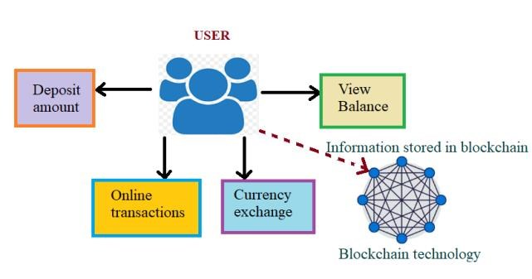*1) New User Signup:*

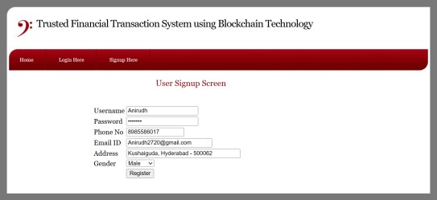Fig. 1. Proposed Architecture

The suggested system design combines human functions with blockchain technology to make sure that financial operations are safe and clear. Users connect with the system in different ways, such as by adding money, checking their accounts, making online purchases, and exchanging currencies.

The system handles the deposit safely and records it on the Blockchain[1] when a user makes a payment. This makes sure that the deal can't be changed, is clear, and can't be hacked. In the same way, when users check their account balances or make purchases online, the system gets the information it needs from the blockchain and changes account balances and transaction records in real time.

Fig. 2. Accessing the Sign-Up Screen

People can sign up for the blockchain-based system through the "New User Signup" feature. To make an account, users enter basic information like their name, contact information, and login information like a username and password. This process makes it easier to make new user accounts, which give people safe access to the platform's features and services.

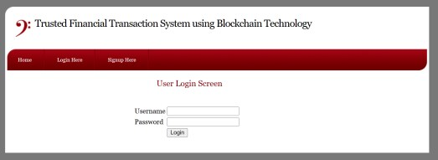*2) User Login:*

When people trade currencies, the system uses blockchain technology to make sure that the deals are safe and that they are recorded. The blockchain stores information about transactions and exchange rates, making sure that everything is clear and correct.

One of the most important parts of the system is blockchain technology, which is an independent and spread record system. Multiple nodes in the blockchain network store data about user activities, account amounts, and exchange rates. This makes sure that the data is reliable and easy to access.

Overall, the system design combines user functions with blockchain technology in a way that doesn't cause any problems. This gives users a safe, quick, and clear way to make financial deals. By using the immutability and digital security of blockchain, the system makes sure that all transactions are honest and correct, which boosts user faith and happiness.

Fig. 3. User Login Screen

The "User Login" feature makes it easy for registered users to get into the system safely. When users enter their login information, the system checks it to make sure they are who they say they are. Once users have been verified, they can use the platform's features and functions. This program makes sure that the login process is safe, which improves the general security of the system and makes it easier for users to get to their accounts.

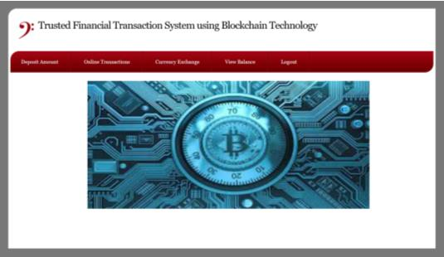iii) *View Balance:*

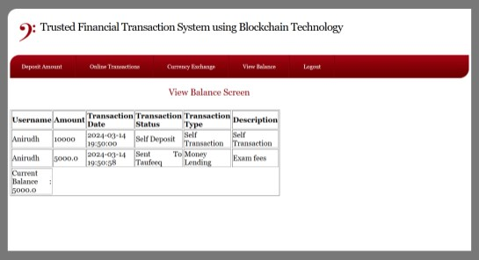Fig. 4. User Dashboard

*i) Deposit Amount:*

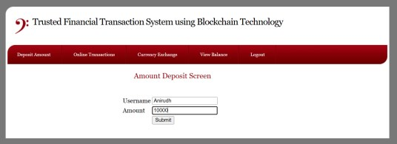Fig. 7. View Balance Screen (Sender)

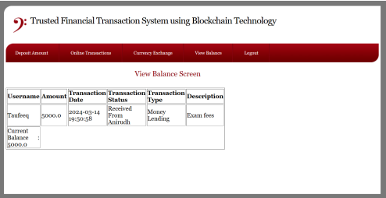Fig. 5. Deposit Amount Screen

The "Deposit Amount" feature lets users add money to their account in the blockchain-based system. This can be standard cash or cryptocurrency. Transactions are handled and stored safely on the blockchain, which makes sure that the whole payment process is open and safe.

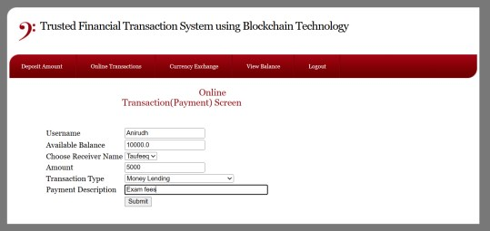*ii) Online Transaction:*

Fig. 8. View Balance Screen (Receiver)

The "View Balance" section lets users see how much money they have in their account and see a log of all the transactions they've made. The blockchain safely records information about payments, withdrawals, swaps, and business wins or losses that users can look at. This function gives people a full picture of all the financial activities going on in the system.

iv) *Currency Exchange:*

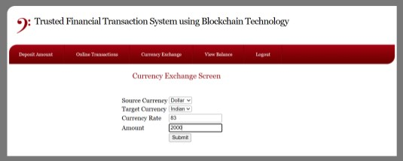Fig. 6. Online Transaction Details Screen

The "Online Transaction" part lets users do a variety of online transactions, such as moving money, paying bills, or investing in financial goods that the site offers. These transactions are safely saved on the blockchain, which gives users an unchangeable and clear record of the transaction history.

Fig. 9. Currency Exchange Screen

The "Currency Exchange" feature lets users change one type of cash into another within the blockchain-based system. This could be regular currency or cryptocurrency. The blockchain

records exchange prices and transaction details. This makes sure that the whole exchange process is clear and accurate, which is good for users' safety and ease.

*D. Blockchain Integration*

1) All payments, online purchases, and currency trades are recorded as blocks on the Ethereum blockchain in the Blockchain-Based System for Money Investment & Secure Transactions. When a block is put to the Blockchain, the information in it can't be changed or removed. This is what "immutable" means. Because of this feature, the transaction data is kept safely and can't be changed, which gives users a lot of trust in the system.

2) Solidity is a computer language for making smart contracts on Ethereum. Smart contracts made in Solidity are a key part of automating financial tasks in the system. These contracts are put into action on the Ethereum Blockchain and have rules and conditions that have already been set. The smart contract does things instantly when certain conditions are met. For example, it transfers money or updates account amounts. By cutting out middlemen and possible mistakes, this technology makes financial processes faster and more accurate.

3) The Ethereum blockchain works on a network of computers called nodes that are not controlled. Every node keeps a copy of the whole Blockchain, which has all the transaction information. This decentralized approach makes it more reliable and easier to use because if one node goes down or isn't available, other nodes still have a full copy of the Blockchain. Users can still view transaction info and complete deals even if some nodes are down for a short time. This autonomous method helps make the system more stable and reliable.

IV. EXPERIMENTAL RESULTS

In contrast to conventional methods of financial transactions, the proposed model relies on the Ethereum blockchain network, renowned for its resilience and adaptability, as the foundation for its implementation in financial transactions. Ethereum's support for smart contracts, which are pre-programmed agreements executing automatically upon meeting specific conditions, serves as a central feature. Leveraging Ethereum's smart contracts, the proposed model simplifies financial processes like payments, trades, and currency exchanges, significantly reducing computational time.

Anchored on the Ethereum blockchain network, the proposed model distinguishes itself through efficiency, security, and cost-effectiveness. Unlike conventional systems dependent on centralized processing and intermediaries, Ethereum's decentralized structure and smart contracts automate

transactions, leading to notable reductions in processing durations. Ethereum's built-in SHA-256 encryption and decentralized ledger further enhance security and reliability, mitigating risks associated with fraud and data breaches. Eliminating intermediaries also diminishes transaction costs, making financial activities more accessible and economical for users.

Additionally, Ethereum's global reach fosters financial inclusion, enabling individuals worldwide to access crucial services. The platform's adaptability and potential for innovation empower developers to tailor solutions to specific requirements, ensuring resilience in the face of changing market dynamics. Ultimately, the proposed model offers a superior alternative to traditional methods, furnishing a secure, efficient, and globally accessible framework for contemporary financial transactions.

V. CONCLUSION

Finally, the addition of blockchain technology to the paper marks the start of a new era of safe, quick, and clear financial activities. Blockchain's digital security and ability to not be changed protect deals from fraud and hacking. Every transaction is hashed using cryptography and kept in a block. This makes sure that the transaction is honest and correct. Additionally, Blockchain [1] greatly speeds up and improves the efficiency of deals, especially those that happen across borders, by getting rid of the need for middlemen and simplifying procedures. This efficient method cuts down on the time it takes to handle transactions, which improves the user experience and lowers costs. Additionally, the paper achieves a fine balance between transaction privacy and openness, protecting privacy while allowing openness through fake names. Cryptographic [3] methods hide the names of the author and receivers while letting users see the details of a transaction. Using the autonomous nature of blockchain, the paper makes sure that data is safe and easy to access. Data is spread out among many network hubs, which keeps the system safe and available even when there are problems. This decentralized method makes the system more stable, giving people safe and dependable access to banking services without a single point of failure. Overall, the paper is a big step toward making the blockchain-powered financial environment safer, more open, and more efficient for everyone.

VI. FUTURE SCOPE

In the future, AI and machine learning could be added to the suggested paper to make it even better by analyzing market data and making personalized investing suggestions. Decentralized identity solutions, such as self-sovereign identity systems, could also be added to make sure that identity proof is safe and can be checked without having to rely on central agencies. These improvements would make the system much more useful, easier

to use, and in line with regulations. They would pave the way for a more complex and user-focused financial environment.

[16] Eyal Ittay, "Blockchain Technology: Transforming Libertarian Cryptocurrency Dreams to Finance and Banking Realities", Computer, vol. 50, no. 9, pp. 38-49, 2017.

REFERENCES

[1] Nakamoto, S. (2008). Bitcoin: A Peer-to-Peer Electronic Cash System.

[2] Tapscott, D., & Tapscott, A. (2016). Blockchain Revolution: How the Technology Behind Bitcoin Is Changing Money, Business, and the World.

[3] World Bank. (2018). Global Findex Database 2017: Measuring Financial Inclusion and the Fintech Revolution.

[4] McKinsey & Company. (2017). Blockchain in Insurance – Opportunity or Threat?

[5] Swanson, T. (2015). Consensus-as-a-service: a brief report on the emergence of permissioned, distributed ledger systems.

[6] Antonopoulos, A. M. (2017). Mastering Bitcoin: Programming the Open Blockchain.

[7] Dhillon, G., & Metcalf, D. (2017). Blockchain Enabled Applications: Understand the Blockchain Ecosystem and How to Make it Work for You.

[8] Buterin, V. (2014). Ethereum: A Next-Generation Smart Contract and Decentralized Application Platform.

[9] Wood, G. (2014). Ethereum: A secure decentralised generalised transaction ledger.

[10] Kawsalya M., Senthil Kumar A. V., Akash V., M. Villanueva Lolit, Shadi Rasheed Masadeh, Anamika Rawat, et. al., “Blockchain-Based Secure Transactions” published in igi global open Access, available at <https://www.igi-global.com/chapter/blockchain-based-secure-transactions/324626.>

[11] Mohd Javaid, Abid Haleem, Ravi Pratap Singh, Rajiv Suman, Shahbaz Khan, et. al., “A review of Blockchain Technology applications for financial services” published in science direct open Access, available at [https://www.sciencedirect.com/science/article/pii/S2772485922000606](https://www.sciencedirect.com/science/article/pii/S2772485922000606.) [.](https://www.sciencedirect.com/science/article/pii/S2772485922000606.)

[12] Tejal Shah, Shailak Jani, et. al., “Applications of Blockchain Technology in Banking & Finance” published in research gate open Access, available at <https://www.researchgate.net/publication/327230927.>

[13] Ye Guo & Chen Liang, et. al., “Blockchain application and outlook in the banking industry” published in springer Access, available at <https://jfin-swufe.springeropen.com/articles/10.1186/s40854-016-0034-9.>

[14] Luis Ruiz-Garcia, G. Steinberger. Rothmund, et. al., “The Application of Blockchain Technology in the Financial Field” published in ieee open Access, available a[t https://ieeexplore.ieee.org/document/9759945.](https://ieeexplore.ieee.org/document/9759945.)

[15] P Treleaven, R G Brown and D Yang, "Blockchain Technology in Finance", Computer, vol. 50, no. 9, pp. 14-17, 2017.

[17] Y. Alabbasi, "Governance and Legal Framework of Blockchain Technology as a Digital Economic Finance", International Journal of Innovation in the Digital Economy, vol. 11, no. 4, pp. 52-62, 2020.

[18] J J Sikorski, J Haughton and M Kraft, "Blockchain technology in the chemical industry: Machine-to-machine electricity market", Applied Energy, vol. 195, no. JUN.1, pp. 234-246, 2017.

[19] M H Miraz and M Ali, "Applications of Blockchain Technology beyond Cryptocurrency", Annals of Emerging Technologies in Computing, vol. 2, no. 1, pp. 1-6, 2018.

[20] S N Wahab, M L Yi and CS. Say, "Antecedents of blockchain technology application among Malaysian warehouse industry", International Journal of Logistics Systems and Management, vol. 37, no. 3, pp. 427, 2020.

[21] H Chai, X Chen and H. Wang, "Special issue: Blockchain technology application", Frontiers of Engineering Management, vol. 7, no. 4, pp. 1-4, 2020.

[22] H Choi and W Y Kun, "An Exploratory Study on Blockchain Technology Application in Fast Fashion Industry: Focused on Reverse Logistics", The e-Business Studies, vol. 20, no. 7, pp. 217-232, 2019.

[23] N Hasan, "Blockchain Technology and its Application in Libraries", Library Herald, vol. 58, no. 4, pp. 118-125, 2020.

[24] V I Ponomare, "DEVELOPMENT OF A DECENTRALIZED VOTING APPLICATION USING BLOCKCHAIN TECHNOLOGY", System technologies, vol. 1, no. 126, pp. 104-110, 2020.

[25] "The future of financial infrastructure," 2017. [Online]. Available: https://www.weforum.org/reports/the-future-of-financial-

infrastructure-an-ambitious-look-at-how-blockchain-can-reshape-financial-services.

[26] J. B. E. F. A. M. S. G. Arvind Narayanan, “Bitcoin and Cryptocurrency Technologies," Princeton University, 2017.

[27] IDRBT , "Applications of Blockchain Technology to Banking & Financial sectors in India," Institute for Development and Research in Banking Technology, Hyderabad, 2017.

[28] "News room/ Press release," 2017. [Online]. Available: <http://www.mahindra.com/news-room/press-release/Mahindra-and-IBM-to-Develop-Blockchain-Solution-for-Supply-Chain-Finance.>

[29] "How Bajaj Electricals uses blockchain to pay suppliers," 2017. [Online]. Available: <http://www.livemint.com/Companies/BcqXQgey9fieFps9xVZxrK/How-Bajaj-Electricals-uses-blockchain-to-pay-suppliers.html.>

[30] "nse looking at blockchain for ensuring settlement guarantees," 2017. [Online]. Available: [http://computer.expressbpd.com/news/nse-looking-at-blockchain-for-ensuring-settlement-guarantees/18956/.](http://computer.expressbpd.com/news/nse-looking-at-blockchain-for-ensuring-settlement-guarantees/18956/)